**Demonstrate how to work with variables in Postman**

Step-1:

First open postman

Step-2:

Then click on Environments

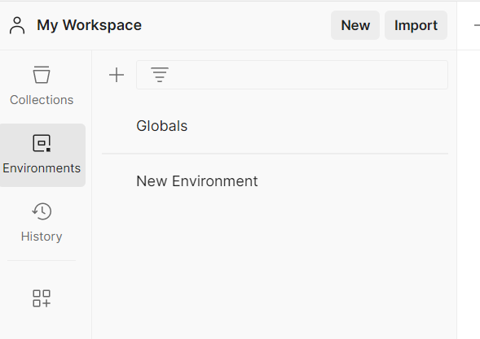

Then I click on Globals

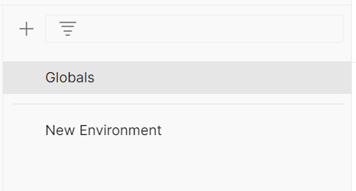

Then I give variable name and value then save it

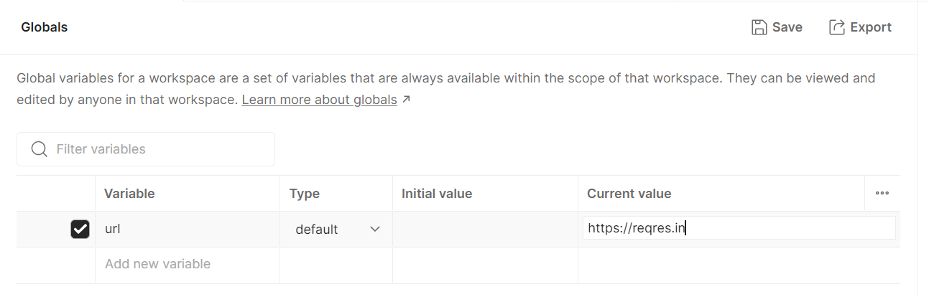

Then here I give the variable within double curly braces and click on send button

